SPRINT - 3

|  |  |
| --- | --- |
| Team ID | PNT2022TMID10261 |
| Project Name | Personal Assistance for Seniors Who Are Self- Reliant. |

1. 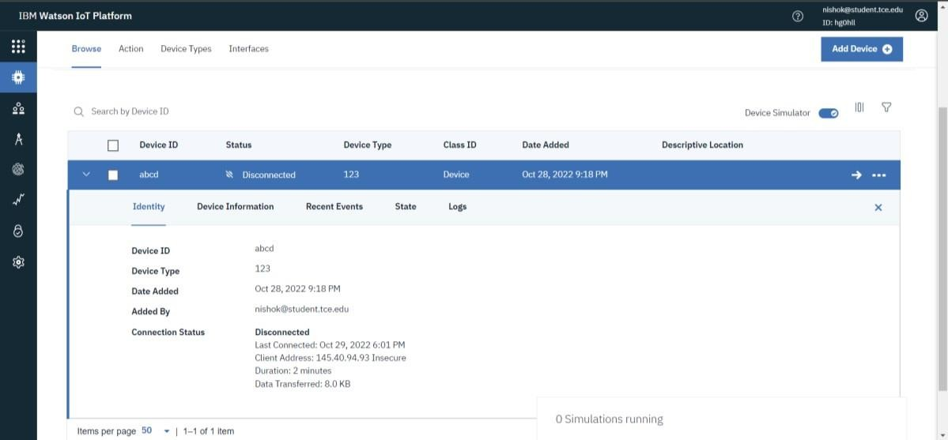Creating IBM Watson IOT Platform and device:
2. Creating Node-RED Service:

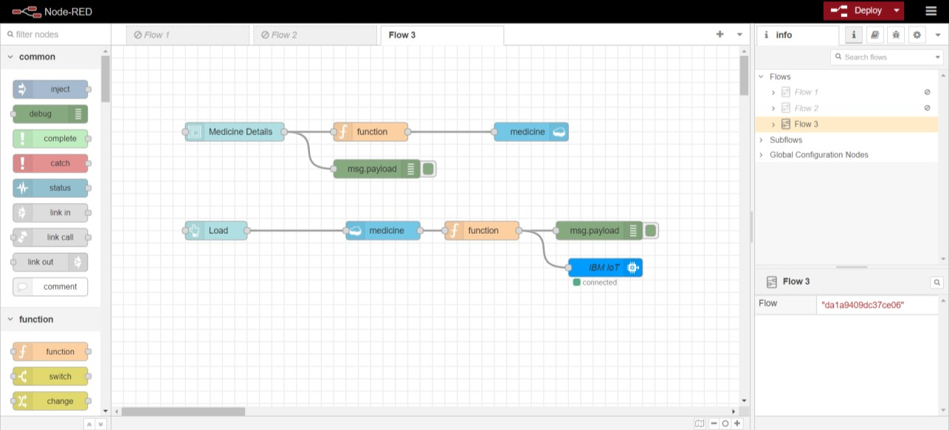

1. 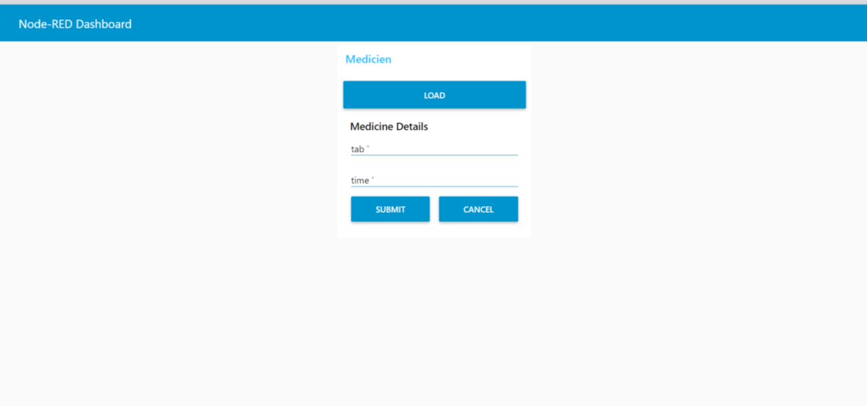Dashboard UI
2. Creating Text to Speech Service:

